**Modeling spatially varying temporal trends in abundance distributions to reveal nuanced changes in complex marine ecosystems**

Spatiotemporal methods for contrasting metrics of species change across multiple spatial scales

Lewis A.K. Barnett1*, Eric J. Ward2, Sean C. Anderson3

1 Resource Assessment and Conservation Engineering Division, Alaska Fisheries Science Center, National Marine Fisheries Service, NOAA, 7600 Sand Point Way N.E, Seattle, WA 98115, USA

2 Conservation Biology Division, Northwest Fisheries Science Center, National Marine Fisheries Service, NOAA, 2725 Montlake Boulevard East, Seattle, ­­WA 98112, USA

3 Pacific Biological Station, Fisheries and Oceans Canada, 3190 Hammond Bay Rd, Nanaimo, BC, V6T 6N7, Canada

* Corresponding author: [lewis.barnett@noaa.gov](mailto:lewis.barnett@noaa.gov)

**Introduction**

In the fields of natural resource conservation, management and global change biology, demand for—and implementation of—tools for assessing species distribution shifts has grown dramatically in recent decades (Elith and Leathwick 2009). These approaches are widely applicable, from studies of plants (Lenoir et al. 2008), terrestrial vertebrates (Hitch & Leberg 2006), and marine fishes (Pinsky et al. 2013). However, the way distribution shifts are quantified has changed relatively little (Elith et al. 2010). At the simplest level, researchers often use existing tools to estimating occurrence probability, presenting maps of how the extent and distribution of suitable habitat is expected to change and perhaps some descriptive statistics on the mean change throughout a region (Yackulic et al. 2013). When reliable abundance data are available distribution shifts are better quantified by spatial predictions of population density, as the notion that the distribution of abundance within a species range is greatest at the center and declines smoothly toward the range edge (the abundant-center hypothesis) has been debunked (Sagarin and Gaines 2002, Sagarin et al. 2006). Shifting ranges may be qualtiatively conveyed through maps but also quantitative spatial indicators may be derived, such as the mean location weighted by abundance (also termed the center of gravity, COG).

In reality, abundance distributions are often quite complex and heterogeneous, even when barriers to dispersal are minimal (cite), let alone in typical marine ecosystems where complex coastline and bathymetric topography and geology interact with physical oceanographic drivers (Levin et al. 2010). Heterogeneity may be present in the distribution of a species throughout its range, but the change in a species over time may also have a spatially varying component. Consequently, attempting to describe a uniform shift in distribution across a broad geographic range can be misleading, particularly when different regions exhibit contrasting trends. For example, if densities increase at opposing range boundaries at an equivalent rate, there may be no trend in the range-wide COG, masking these finer-scale shifts. Thus, when using spatial indicators to describe species distribution shifts, the spatial scale of aggregation can affect the inference, as in the classic problem of pattern and scale in ecology (Levin 1992). Therefore, there is a general need to develop objective methods for defining appropriate scales to evaluate changes in species distributions. Such tools are widely applicable for solving specific problems in fish and wildlife conservation and management by defining spatial domains with distinct population dynamics.

One of the most rapidly evolving applications of models to predict species’ range shifts has been in the field of commercial fisheries management. In addition to having ecological implications, changes in the spatial distribution of marine fishes has implications for national food security (Rice et al. 2011). The most reliable estimates of marine fish density are generally derived from fishery-independent survey data; these surveys may also collect additional information valuable in inferring population status, such as age or sex structure (Hilborn and Walters 1992). In addition to providing data used for managing individual fish populations, fishery-independent survey data may also be used to provide indicators for ecosystem assessments (Nicholson and Jennings 2004, Harvey et al. 2018), understanding the impacts of fishing on non-target species (Stock et al. 2019), or informing reference points in applications of ecosystem based fisheries management (Link et al. 2002).

Techniques for estimating how fish populations vary over space and time have evolved rapidly over the last 5 years. The largest methodological changes have been advances in spatiotemporal modeling that have modeled space continuously and explicitly accounted for spatial autocorrelation between spatially-referenced observations that are proximate in both space and time (Shelton et al. 2014, Thorson et al. 2015). These newer analytical approaches replaced conventional design- or strata-based estimators, which assumed that density is homogenous within strata (Chen et al. 2004). These newer modeling tools have become accessible in open source software, such as VAST (Thorson 2019) and as a result these approaches have been applied to fish populations in diverse ecosystems around the world. In addition to being used for estimating abundance or spatial distributions, output from these modeling approaches have been used to generate model-based summaries to track change in species distributions, including center of gravity (COG) or area occupied, with more robust estimation than those provided by design-based estimates (Thorson et al. 2016).

There are a number of advantages of estimating a species’ density in a framework that accounts for spatial or spatiotemporal variation. First, explicitly accounting for spatial variation in density has been shown to increase precision of estimated temporal trends (Thorson et al. 2015). Second, the framework used in the majority of approaches for modeling spatial or spatiotemporal variation in fish density is extremely flexible and extendable. Approaches include using mixed models where the spatial or spatiotemporal components are typically estimated as random effects (Latimer et al. 2009, Shelton et al. 2014) and annual effects are included as factors to allow for unbiased estimates of trends. Additional extensions include the incorporation of covariates such as depth (Johnson et al. 2019), modeling extremes in spatial processes (Anderson and Ward 2019) or using non-Gaussian families for the response variable to better capture both zeros and extremes (Shono 2008).

Conveying changes in the spatial distribution of a species estimated from existing spatiotemporal models may be complicated, particularly for non-scientific audiences. These challenges are similar to non-spatial settings, such as interpreting rates of change from linear mixed models. For the spatial setting, focal questions of interest may include how the estimated deviations change through time, or whether they are autocorrelated. Similar to the non-spatial case, recently developed spatiotemporal modeling approaches have all treated time as a discrete factor, and assumed the predicted spatial distribution of density to be constant across time (modeled as a single spatial field) or variable over time (with variability modeled either as independent over time, or as an autoregressive process).

The objective of this manuscript is to introduce a new modeling approach, explicitly accounting for the spatial variability in how species change through time. While widely applicable to a wide range of biological data (or even non-biological data), we focus on an application to changes in the distribution for commercially fished species. These represent 19 species from a 15-year publically available trawl survey dataset. We illustrate how our new approach may be used to infer changes over time, and also how output from this modeling approach may be useful in identifying spatial regions where change is greater than or less than average. We demonstrate how model-based COG estimates for these subregions may be more useful than global COG trends calculated over an entire survey domain.

**Methods**

*Spatial GLMM Overview*

The majority of recent applications of SDMs to fisheries data have been implemented in a GLMM (generalized linear mixed‐effects model) framework, where random effects are used to describe and spatial or spatiotemporal components. Spatial components are differentiated from spatiotemporal components in that the former are constant, whereas the latter vary through time. Examples include applications to Gaussian predictive process models (Shelton et al. 2014, Thorson et al. 2015, Anderson and Ward 2019), and predictive modeling using integrated nested Laplace approximations (INLA; (Rue et al. 2009, Ruiz-Cárdenas et al. 2012)). The latter approach has been particularly useful for large datasets, where large gains in computational efficiency are accomplished by taking advantage of sparse matrix approximations to the variance – covariance matrix (Thorson and Barnett 2017). Regardless of the estimation approach used, the general formulation of these models uses a link function $g(∙)$ to relate the observed response to covariates and a latent spatial process. For example,

$g\left(u_{s,t}\right)=X_{s,t}B+{ω_{s}+γ}_{s,t}$,

where $u_{s,t}$ is the expectation at location *s* and time *t*, $X_{s,t}$ are covariates, $B$ represents a vector of estimated coefficients, $ω_{s}$ is the mean spatial component at location *s* (constant through time), and $γ_{s,t}$ is the spatiotemporal process at location *s* and time *t*. The spatiotemporal process describing $γ$ is flexible in that it can be removed from the model (leaving a model with a spatial but no spatiotemporal component), may be independent for each time slice, or modeled with an autoregressive process (allowing hotspots to persist through time; (Thorson et al. 2015, Ward et al. 2015, Anderson and Ward 2019)). Previous applications to marine fishes have either used a delta-GLMM framework to model presence-absence and positive catch rates separately (Thorson et al. 2015) or a Tweedie distribution to model total variation in density (Shono 2008).

Within this GLMM framework, non-stationary changes in the spatial predictions through time can only be modeled with inclusion of covariates, or by modeling spatiotemporal variability as an autoregressive spatial process through time. To explicitly account for non-stationary trends in densities, we extend the above framework to include a trend parameter as an additional spatial field. Extending the model above, this becomes

$g\left(u_{s,t}\right)=X_{s,t}B+{ω_{s}+γ}_{s,t}+{t∙z}_{s}$,

where $z_{s}$ represents the spatially varying temporal trend. This trend field can be thought of as the spatial variability in how a species changes through time (Figure 1).

*Testing the ability to recover spatial trends*

To evaluate our ability to recover an added spatial field representing the trend, we conducted a simulation analysis. Given results from previous work with state space models (Auger-Methe et al. 2016), we focused our simulations on understanding how the magnitude of spatiotemporal variation or observation error variation affect our ability to recover the spatial trend. The simulations were conducted as follows: for each value of spatiotemporal variation and observation error, we simulated a random spatial field. We then simulated a latent spatiotemporal process over 10 time steps, using spatial and spatiotemporal components (modeled as independently year to year) along with a spatial field representing the temporal trend. To include measurement or observation error, we simulated normally distributed data from this spatiotemporal process. We then fit a spatial GLMM to the simulated data, and assumed the model structure to be known. Estimated values of the spatial trend at the locations of the data were vectorized for each simulation, and used with the known values to generate statistical summaries (bias, variance, correlations between predicted and observed values). For each combination of parameter values, we simulated 100 random datasets. Code to replicate this analysis is included in the repository for this project.

*West coast groundfish application*

As an example, we fit the spatial trend model to groundfish data collected from a fishery-independent survey along the US west coast: the NOAA Fisheries, Northwest Fisheries Science Center, US West Coast Groundfish Bottom Trawl Survey (Keller et al. 2017). This survey collects an average of more than 600 samples per year from May to October at depths from 55 to 1280 m, from the US-Canada border to the US-Mexico border. We analyzed the 2003–2018 surveys, which consisted of 10,354 samples, where locations were selected randomly on trawlable seafloor habitat (i.e., areas without extensive rocks or boulders) stratified by depth and latitude. This survey represents an ideal case study, because it has been used extensively in testing new index standardization methods for stock assessments (Thorson et al. 2015), is publicly available (<https://www.nwfsc.noaa.gov/data/map>), and has been used to develop coastwide indicators, including shifts in center of gravity (Thorson et al. 2016). We selected 19 groundfish species to model in this analysis, chosen based on a combination of high commercial landings, market value, conservation concern, and prevalence in the survey data (Table S1).

To evaluate whether the spatial trend may be appropriate for modeling how these 19 species change over time, we fit spatial GLMMs with and without a spatial trend to each species. We allowed both models to include spatial and spatiotemporal components (independent by year), depth modeled as a quadratic effect (Thorson et al. 2015), and year as a factor. Spatial components were modeled as random fields, using a triangulated mesh with vertices at 350 knots to approximate a continuous spatial field. The inclusion of year as a factor centered each of the estimated spatiotemporal fields to have mean zero. Because of the skewed distribution and zero-inflation in the recorded catches (catch per unit effort, CPUE), we modeled the response with a Tweedie distribution (log link) (Shono 2008). All estimation was done in R (R Core Team 2018) in a maximum likelihood framework, using the package sdmTMB (cite Sean) which interfaces automatic differentiation in Template Model Builder (Kristensen et al. 2016) with INLA (Rue et al. 2009). Because we were interested in comparing models with different random effects structures (with and without the spatial trend field), we used restricted maximum likelihood (REML, Zuur et al. 2009) to generate Akaike’s Information Criterion values for each (AIC, (Akaike 1973)). Using AIC as a model screening tool, we found broad support for the inclusion of the spatial trend for these 19 species, with the trend model generating lower AIC values in 17 of the 19 cases, and AIC scores differed by less than 2 in the remaining 2 cases (Table S2).

(Fig. 2).To obtain a smooth surface of predicted density across the footprint of the survey area, we predicted biomass density from the spatial trend models using depth defined by NOAA bathymetry data (https://www.ngdc.noaa.gov/mgg/coastal/crm.html), averaged over space to match the resolution of the survey sampling grid (~2.8 x 3.7 km), which is the spatial resolution we used for all analyses. A number of diagnostics could be made to these predictions or raw model fits to further diagnose whether a spatial trend may be appropriate; examples include examining spatial patterns in residuals or the estimated spatiotemporal component.

*Using spatial trends as indicators of change*

As a demonstration of the utility of understanding finer scale temporal trends, we calculated regional metrics (change in density, area occupied, COG), and compared those fine scale metrics to their coastwide equivalents. Quantifying change at multiple spatial scales has implications for the management of marine fishes, and has utility as a spatial indicator within the California Current ecosystem. Spatial trend estimates from our model can be used to identify discrete areas of change. One approach for doing this is to apply post-hoc cluster analyses to model outputs or covariates; for our groundfish application, we used the partitioning around mediods algorithm in the fpc R library (Hennig 2019). Latitude and the predicted spatial trends were used as clustering variables given that the majority of the contrast in dynamics along the US west coast is in the latitudinal direction. Other metrics could also be included in clustering – including longitude, habitat features, environmental covariates, or human impacts such as fisheries removals.

**Results**

*Simulation testing*

Results from our simulation indicated that, as expected, both observation error variation and spatiotemporal variation degraded our ability to estimate the true spatial trend (Fig. 3). When both variance parameters are small, estimates are precisely estimated and unbiased, however large values of either can destroy the ability to recover the trend (Fig. 3). The performance of these models is also conditional on additional parameters and structure not included in our sensitivity analysis (e.g. spatial decay and variation parameters), however these results indicate that spatiotemporal variation has a slightly larger effect on our ability to recover trends than does observation error (comparison of rows in Fig. 3).

*West coast groundfish application*

Predictions of the spatially-explicit trend from the spatial trend model revealed intricate fine-scale spatial structure and rates of change of species in the west coast groundfish community. Our cluster analysis of the estimated spatial trend and latitude helped delineate areas with the greatest relative rate of change in density over time. Among all 19 species, typically at least one of the breaks between clusters occurred at a latitude corresponding to a recognized biogeographic break (Fig. 4). These locations of similarity between the boundary of the spatial trend clusters occurred most often near Point Conception in southern California, and Cape Mendocino in northern California. Approximately 14-15 species had cluster boundaries near Cape Mendocino, with roughly 6-7 near Point Conception, and nearly all major cluster breaks occurred within latitudes between Cape Mendocino and Point Conception. However, there was some variability among species in the precise location of the boundary of the spatial trend cluster. Given the general proximity between trend cluster breaks and the established biogeographic boundaries, we chose to evaluate the latitudinal center of gravity (COG) within each biogeographic region to compare with the coastwide COG.

We highlight results for six groundfish species with unique distributional responses (Fig. 5; see Figs. S1-3 for results from all 19 species). Within each of the six species, there was support for 2-3 trend (Fig. 5; second column). Comparison of the spatial trend predictions and clusters (Fig. 5; first two columns) and the mean distribution of density from the full model (Fig. 5; third column) revealed how several unique patterns of subregional relationships can contribute to nuanced and difficult to detect broad-scale distributional changes including northward, southward, and bi-directional range shifts, in addition to localized offshore shifts. Furthermore, the interpretation of the observed distributional change often varied between spatial scales of interpretation, along the spectrum from summarizing trends in the coastwide latitudinal COG to regional COGs, and fine-scale map-based interpretation. In the map of estimated maps of density as a way to visually weight the spatial trend map to better understand where absolute changes in density are greatest.

Examining the predictions of the spatial trend and mean density indicated that arrowtooth flounder had a southward range shift and shortspine thornyhead had a northward range shift, yet the COG inferences differed to some degree between species. The predicted mean density indicated that the majority of arrowtooth flounder density was in the northern region (Fig. 5, first row), yet the spatial trend pattern indicates that their density is increasing at the highest rate in the central region. Combined, these regional results suggest a southward range expansion toward the range edge. The time series of the coastwide COG (black line in last column of Fig. 5) is in agreement of a southward shift, yet the interpretation is not as clear because the coastwide pattern is heavily weighted by the high densities in the far northern portion of the study area. When the COG from each biogeographic region is calculated (colored lines in last column of Fig. 5), we can see that coastwide COG has been driven further south by decreases in the COG in the central region in latter halftime seriesestimates from the north and south appear to converge, providing someadditional support the possibilitysupport that the change is due to increased density or southward shifts in the central region. For other species in our analysis, even the region-specific COG does not accurately capture the nuanced spatial changes described by the spatial trend field. For example, shortspine thornyhead is distributed coastwide, yet they are increasing fastest in the north-central area and decreasing in the south and within some isolated patches in the far northern end of the region (Fig. 5, last row). In this case, the coastwide COG indicates a northward distribution shift, yet the region-specific COG indicates converging trends: slightly southward shifting of the northern region and slight northward shift in the central region. Thus, the interpretation from the COGs at both scales are relatively consistent with the fine-scale interpretation of the spatial trend, yet do not reflect the complete pattern of change, as it does not convey the decrease in density in the southern region.

The spatial trend and density maps indicated northward range shifts for bocaccio rockfish, where the former also had a localized shift in longitude from nearer to further from shore in the northern portion of the region. Both species were typically more abundant in the southern and central areas, yet were experiencing the fastest increases in density in the north. These observations contrast with those from the COG, where the coastwide COG for bocaccio is highly variable with either no trend or a very slight southward trend, yet the COG of the northern region indicates a southward shift among some years.

A bi-directional or divergent range shift was observed in the spatial trend of English sole, which is typically present in relatively similar densities coastwide. However, the coastwide COG reveals only a slight southward shift, while the region-specific COGs shows only a slight northward shift in the northern region.

No range shift was apparent in maps of the spatial trend and density for sablefish, yet the coastwide COG timeseries indicated that a northward shift had occurred in the most recent 5-6 years. The region-specific COG indicates that this was driven by density changes in the northern and to some extent central regions. Thus, depending on the evidence used, one could either conclude that there was a recent northward range shift, or simply an increase in productivity or aggregation near the core of the range within the north-central area.

**Discussion**

Ecosystems are often complex in their spatial distribution of biotic and abiotic drivers of population productivity and habitat suitability, suggesting that fine-scale descriptors may provide a more accurate representation of changes in species distributions than global indicators calculated across an entire region. Here, we introduced a new approach to modeling and summarizing spatially-referenced time series data on species abundances to calculate area-specific trends in population density. Our new method was able to recover spatial trends in simulated data, and reveal nuanced spatial trends in in the dynamics of 19 marine fishes off the west coast of the USA that often differed from conventional descriptors of larger scale distribution shifts (Woillez et al. 2009, Pinsky et al. 2013, Thorson et al. 2016). Furthermore, the ability of our models to detect geographic boundaries between regions with different trends was affirmed as these boundaries were largely congruent with known biogeographic breaks.

Simulations indicated that models including a spatial trend field were more parsimonious than those without a spatial trend. This result is consistent with a recent study using incorporating a spatially varying influence of an oceanographic index on groundfish distributions in the eastern Bering Sea (Thorson 2019a). Furthermore, the estimated spatial trends were less biased than those estimated post-hoc from predictions of a model without the spatial trend field. The spatial trend model is robust to model misspecification, but as expected somewhat sensitive to observation error and spatiotemporal variation. Such sources of variation can obscure the spatial trend, yet this is to be expected in the same way that any trend is less detectable given greater noise in the data (one general citation/one more specific to spatiotemporal models). Our method may be generally skillful at detecting spatial structure in population or community dynamics from observations with precise measurement within systems with low temporal variation in spatial structure (e.g., those consisting of species with slower life histories and lower variation in dispersal paths). Further ways to constrain the variance parameters, such as developing informative Bayesian priors from similar surveys

We show how the inference about shifts in species distribution or productivity depend on the spatial scale at which they are summarized. When we applied the spatial trend model to the data in our application to marine fishes, the resulting maps of the spatially-explicit trend and mean density from the model revealed nuanced patterns of heterogeneity and directional change in groundfish biomass distributions (COG; this study, (Thorson et al. 2016)). Taking the mean density to represent the underlying spatial heterogeneity, the trend random field conveyed fine-scale information about potential range dynamics that often differed from related inferences made by evaluating time series of the coastwide COG of predicted density. The disparity of inference was greatest in cases where density was increasing fastest at opposing ends of a range, a divergent shift, or where densities among patches were converging toward the center of the distribution. Furthermore, from the coastwide COG, without further investigation one is unable to differentiate between shifts due to an increase in density in one dimension or a decrease in density in the opposite dimension. However, partitioning by latitude and trend identified clusters of locations, within which the COG of predicted density still has promise as a useful summary statistic of distribution shifts.

For complex ecosystems such as the US west coast and other coastal upwelling systems, where physical variables like temperature do not follow a simple monotonic gradient over broad geographic scales, it may be too simplistic to expect clear coastwide trends in COG across multiple species as a result of climate change. These types of patterns are observed in systems with broader continental shelves like the northeast US (Pinsky et al. 2013, Kleisner et al. 2016), yet along coastlines with narrower continental margins, depending on the orientation and slope of the bathymetry, fish may be able to find equivalent temperatures by moving much shorter distances perpendicular to the shelf break. Furthermore, population and community biomass is inherently patchy, meaning that detecting meaningful redistribution over time may require careful examination of the microstructure of biomass distribution rather than a region-wide shift in mean biomass distribution. We encourage future research on species distribution shifts that begins with more specific and nuanced hypotheses regarding the expected response. For example, if climate change causes a global intensification of upwelling as some researchers predict (Bakun et al. 2010), one could hypothesize that biomass distributions will become patchier over time in response to increasing contrast in local physical conditions, or that distributions will shift deeper as larvae are transported further offshore before settling.

The future of fisheries and wildlife management relies on greater incorporation of spatial information into models and decision-making processes (Berger et al. 2017, Lowerre-Barbieri et al. 2019). By defining the geography of population trends and the breaks between clusters of locations with similar trends, our modeling framework provides a data-driven method to objectively define the spatial scale and boundaries for summarizing monitoring data and structuring these inputs to resource management models. This is an important advancement over non-spatial resource assessments or the reliance on the use of jurisdictional boundaries to structure assessments. Our vision is that these and subsequent methods for boundary detection will aid the development of spatial fishery stock assessment models and stimulate further applications of such approaches to more disparate management solutions such as invasive species management.



Figure 1. Visualization of the spatiotemporal component of a GLMM, with and without a spatial trend (spatiotemporal fields in time steps 1 through 5 are shown). In the absence of a trend the spatiotemporal fields offer a flexible approach to model the data, though there is a persistent trend in the fields over time. After removing this trend, spatiotemporal fields are included to explain the residual spatial variation.

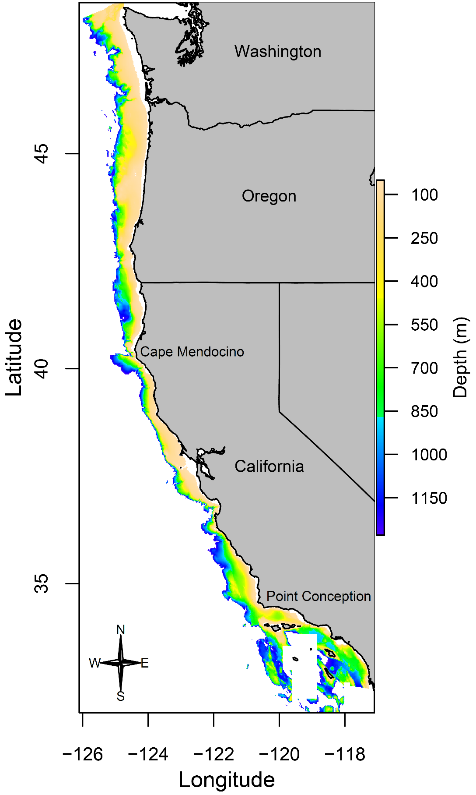

Figure 2. Map of the bathymetry within the US west coast groundfish bottom trawl survey area. Cape Mendocino and Point Conception are labeled to represent the latitudinal boundaries between known biogeographic regions.

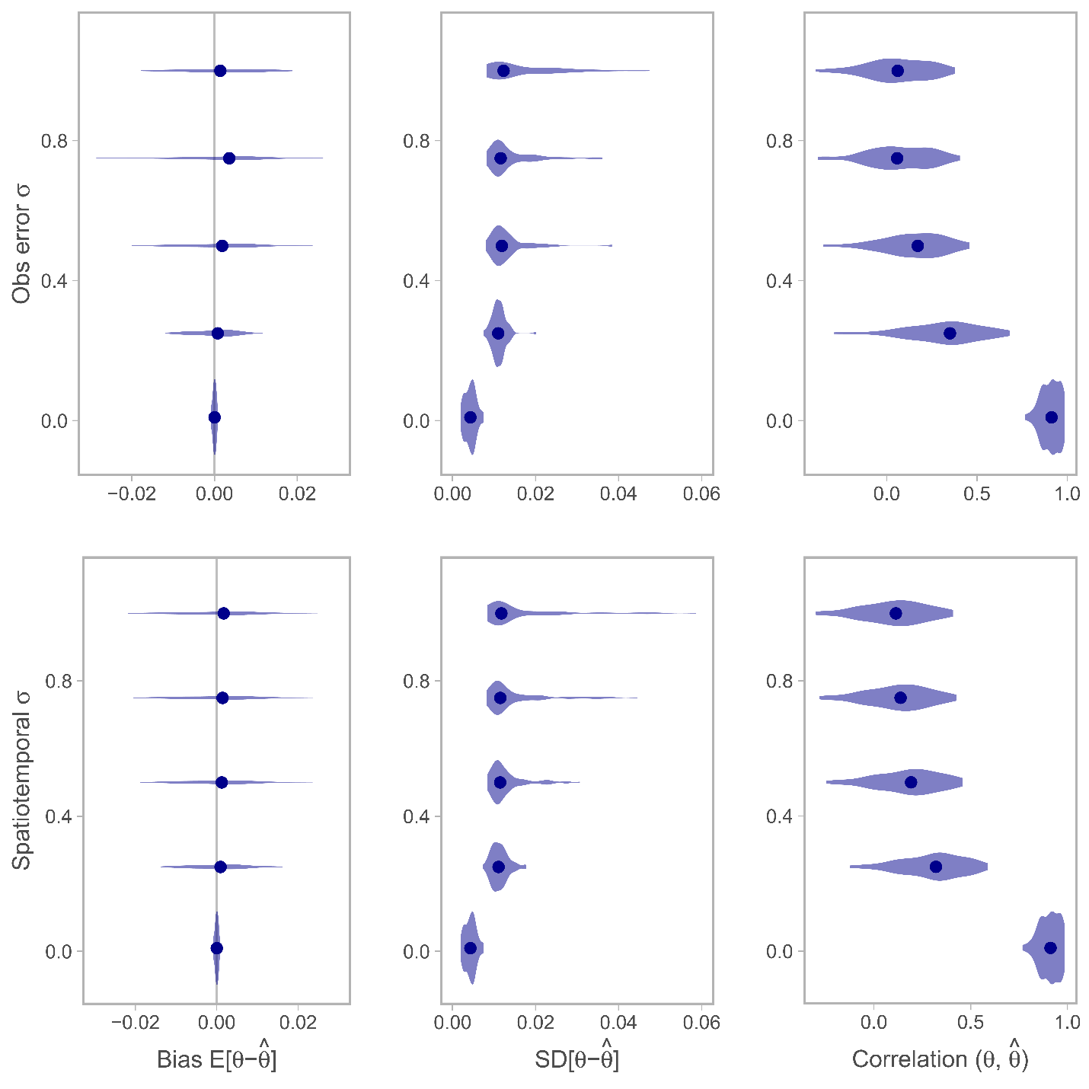

Figure 3

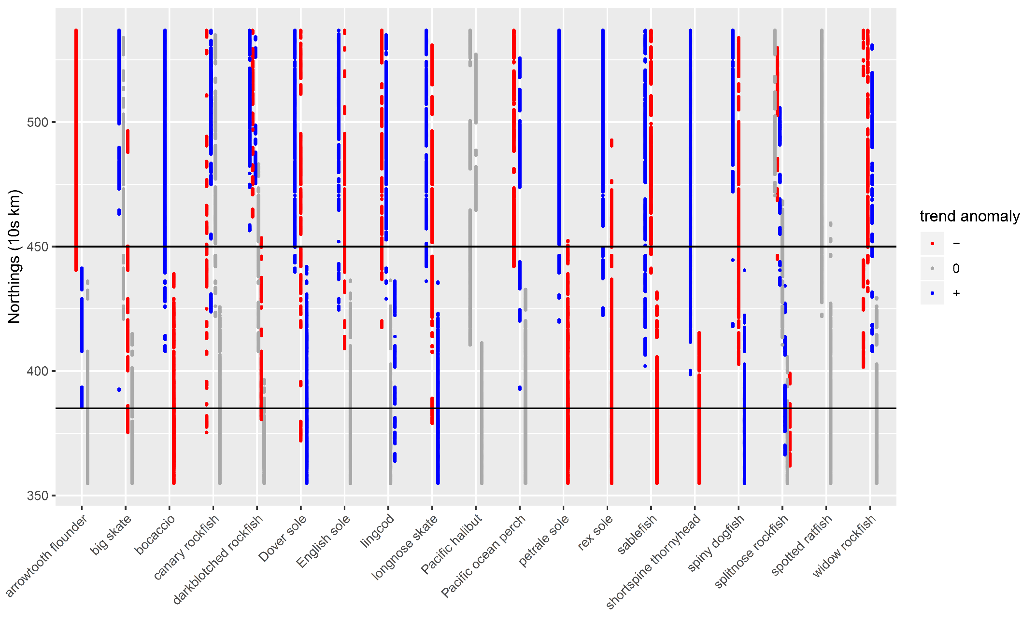

Figure 4. Stripplot showing each unique cluster of latitude and spatial trend in density (slope) by species. Each set of points associated with a given cluster are represented by a different column and colored by their deviation from the mean coastwide trend for a given species. Grey points represent clusters from which the trend (slope) was within 0.01 of the mean coastwide trend. Horizontal lines represent approximate positions of known biogeographic breaks: Cape Mendocino, California in the north; Point Conception, California in the south).

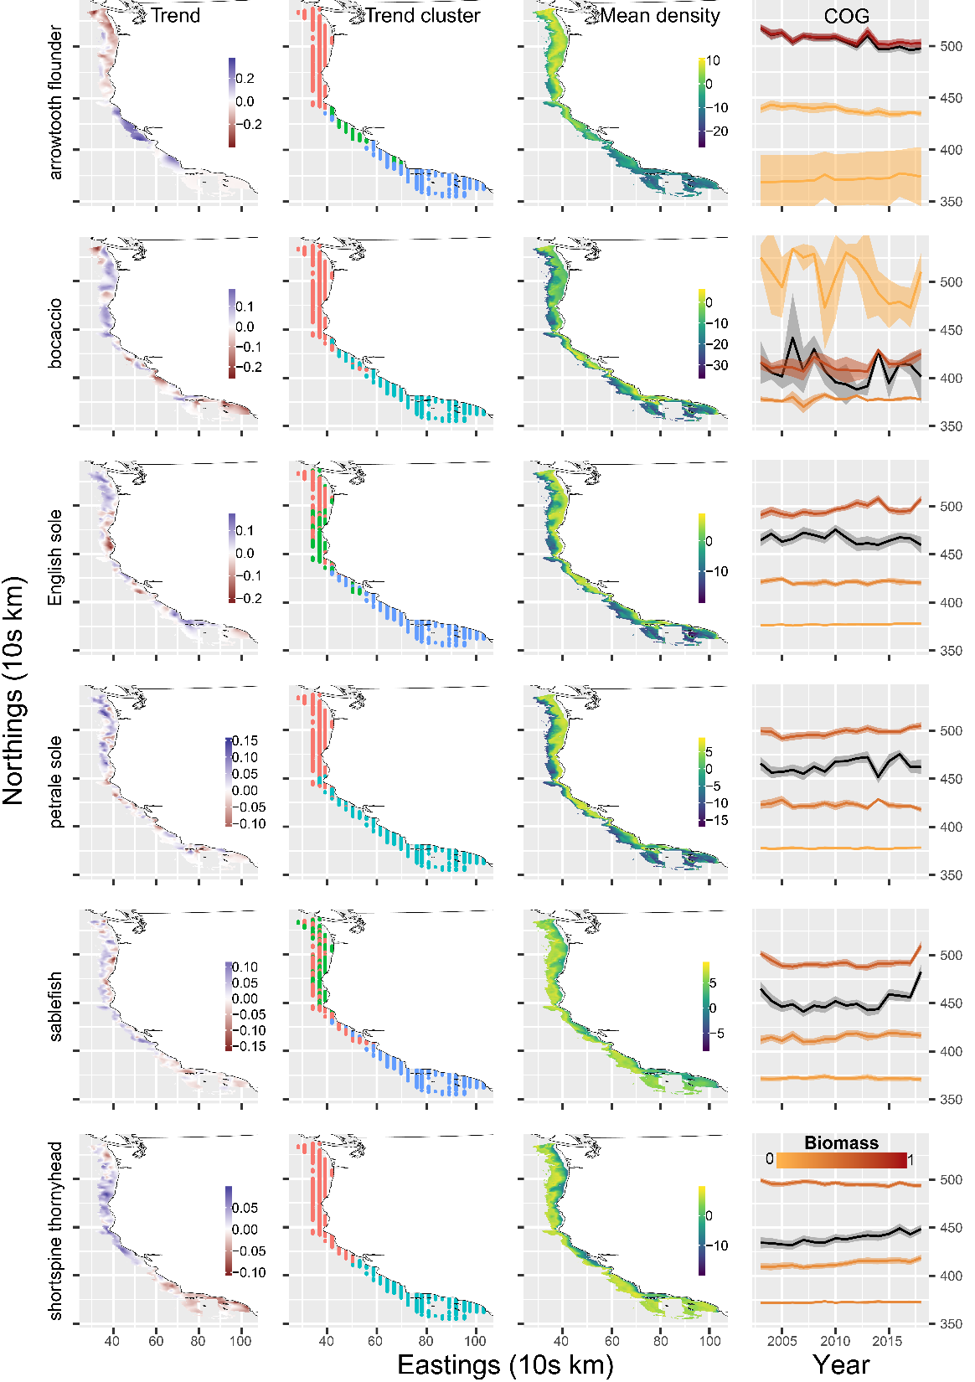

Figure 5. Spatial and temporal patterns of predicted density for selected species. The first column shows maps of the predicted spatial trend (slope of log density across years). The second and column shows how each spatial location groups with a unique cluster of latitude and spatial trend. The fourth column shows the time series of the center of gravity (COG), or density-weighted mean latitude with 95% confidence intervals. The black line with grey interval represents the COG calculated on coastwide predicted species density, whereas the colored lines are the COGs for each unique biogeographic region (separated by Cape Mendocino, California in the north; Point Conception, California in the south). Line color represents the proportion of a species biomass in a given region.

REFERENCES

Akaike, H. 1973. Information theory and an extension of the maximum likelihood principle. Page 2nd International Symposium on Information Theory. Budapest: Akadémiai, Tsahkadsor, Armenia, USSR.

Anderson, S. C., and E. J. Ward. 2019. Black swans in space: modeling spatiotemporal processes with extremes. Ecology 100:e02403.

Bakun, A., D. B. Field, A. Redondo-Rodriguez, and S. J. Weeks. 2010. Greenhouse gas, upwelling-favorable winds, and the future of coastal ocean upwelling ecosystems. Global Change Biology 16:1213–1228.

Berger, A. M., D. R. Goethel, P. D. Lynch, T. Quinn, S. Mormede, J. McKenzie, and A. Dunn. 2017. Space oddity: The mission for spatial integration. Canadian Journal of Fisheries and Aquatic Sciences 74:1698–1716.

Chen, J., M. E. Thompson, and C. Wu. 2004. Estimation of Fish Abundance Indices Based on Scientific Research Trawl Surveys. Biometrics 60:116–123.

Elith, J., M. Kearney, and S. Phillips. 2010. The art of modelling range-shifting species. Methods in Ecology and Evolution 1:330–342.

Elith, J., and J. R. Leathwick. 2009. Species Distribution Models: Ecological Explanation and Prediction Across Space and Time. Annual Review of Ecology, Evolution, and Systematics 40:677–697.

Harvey, C., N. Garfield, G. Williams, N. Tolimieri, I. Schroeder, E. Hazen, K. Andrews, K. Barnas, S. Bograd, R. Brodeur, B. Burke, J. Cope, L. deWitt, J. Field, J. Fisher, T. Good, C. Greene, D. Holland, M. Hunsicker, M. Jacob, S. Kasperski, S. Kim, A. Leising, S. Melin, C. Morgan, B. Muhling, S. Munsch, K. Norman, W. Peterson, M. Poe, J. Samhouri, W. Sydeman, J. Thayer, A. Thompson, D. Tommasi, A. Varney, B. Wells, T. Williams, J. Zamon, D. Lawson, S. Anderson, J. Gao, M. Litzow, S. McClatchie, E. Ward, and S. Zador. 2018. Ecosystem Status Report of the California Current for 2018: A Summary of Ecosystem Indicators Compiled by the California Current Integrated Ecosystem Assessment Team CCIEA. U.S. DEPARTMENT OF COMMERCE National Oceanic and Atmospheric Administration National Marine Fisheries Service Northwest Fisheries Science Center.

Hennig, C. 2019. Fpc: flexible procedures for clustering.

Hilborn, R., and C. J. Walters. 1992. Quantitative fisheries stock assessment: Choice, dynamics and uncertainty. Chapman & Hall, London.

Johnson, K. F., J. T. Thorson, and A. E. Punt. 2019. Investigating the value of including depth during spatiotemporal index standardization. Fisheries Research 216:126–137.

Keller, A. A., J. R. Wallace, and R. D. Methot. 2017. The Northwest Fisheries Science Center’s West Coast Groundfish Bottom Trawl Survey: History, Design, and Description. NOAA Technical Memorandum, Northwest Fisheries Science Center, Seattle, WA.

Kleisner, K. M., M. J. Fogarty, S. McGee, A. Barnett, P. Fratantoni, J. Greene, J. A. Hare, S. M. Lucey, C. McGuire, J. Odell, V. S. Saba, L. Smith, K. J. Weaver, and M. L. Pinsky. 2016. The Effects of Sub-Regional Climate Velocity on the Distribution and Spatial Extent of Marine Species Assemblages. PLOS ONE 11:e0149220.

Kristensen, K., A. Nielsen, C. W. Berg, H. Skaug, and B. M. Bell. 2016. TMB: Automatic Differentiation and Laplace Approximation. Journal of Statistical Software 70:1–21.

Latimer, A. M., S. Banerjee, H. S. Jr, E. S. Mosher, and J. A. S. Jr. 2009. Hierarchical models facilitate spatial analysis of large data sets: a case study on invasive plant species in the northeastern United States. Ecology Letters 12:144–154.

Levin, S. A. 1992. The problem of pattern and scale in ecology: the Robert H. MacArthur award lecture. Ecology 73:1943–1967.

Link, J. S., J. K. T. Brodziak, S. F. Edwards, W. J. Overholtz, D. Mountain, J. W. Jossi, T. D. Smith, and M. J. Fogarty. 2002. Marine ecosystem assessment in a fisheries management context. Canadian Journal of Fisheries and Aquatic Sciences 59:1429–1440.

Lowerre-Barbieri, S. K., I. A. Catalán, A. Frugård Opdal, and C. Jørgensen. 2019. Preparing for the future: integrating spatial ecology into ecosystem-based management. ICES Journal of Marine Science 76:467–476.

Nicholson, M. D., and S. Jennings. 2004. Testing candidate indicators to support ecosystem-based management: the power of monitoring surveys to detect temporal trends in fish community metrics. ICES Journal of Marine Science 61:35–42.

Pinsky, M. L., B. Worm, M. J. Fogarty, J. L. Sarmiento, and S. A. Levin. 2013. Marine taxa track local climate velocities. Science 341:1239–1242.

R Core Team. 2018. R: A language and environment for statistical computing. Vienna, Austria.

Rue, H., S. Martino, and N. Chopin. 2009. Approximate Bayesian inference for latent Gaussian models by using integrated nested Laplace approximations. Journal of the Royal Statistical Society: Series B (Statistical Methodology) 71:319–392.

Ruiz-Cárdenas, R., E. T. Krainski, and H. Rue. 2012. Direct fitting of dynamic models using integrated nested Laplace approximations — INLA. Computational Statistics & Data Analysis 56:1808–1828.

Shelton, A. O., J. T. Thorson, E. J. Ward, and B. E. Feist. 2014. Spatial semiparametric models improve estimates of species abundance and distribution. Canadian Journal of Fisheries and Aquatic Sciences 71:1655–1666.

Shono, H. 2008. Application of the Tweedie distribution to zero-catch data in CPUE analysis. Fisheries Research 93:154–162.

Stock, B. C., E. J. Ward, T. Eguchi, J. E. Jannot, J. T. Thorson, B. E. Feist, and B. X. Semmens. 2019. Comparing predictions of fisheries bycatch using multiple spatiotemporal species distribution model frameworks. Canadian Journal of Fisheries and Aquatic Sciences.

Thorson, J. T. 2019a. Measuring the impact of oceanographic indices on species distribution shifts: The spatially varying effect of cold-pool extent in the eastern Bering Sea. Limnology and Oceanography 64:2632–2645.

Thorson, J. T. 2019b. Guidance for decisions using the Vector Autoregressive Spatio-Temporal (VAST) package in stock, ecosystem, habitat and climate assessments. Fisheries Research 210:143–161.

Thorson, J. T., and L. A. K. Barnett. 2017. Comparing estimates of abundance trends and distribution shifts using single- and multispecies models of fishes and biogenic habitat. ICES Journal of Marine Science 74:1311–1321.

Thorson, J. T., M. L. Pinsky, and E. J. Ward. 2016. Model-based inference for estimating shifts in species distribution, area occupied and centre of gravity. Methods in Ecology and Evolution 7:990–1002.

Thorson, J. T., A. O. Shelton, E. J. Ward, and H. J. Skaug. 2015. Geostatistical delta-generalized linear mixed models improve precision for estimated abundance indices for West Coast groundfishes. ICES Journal of Marine Science 72:1297–1310.

Ward, E. J., J. E. Jannot, Y.-W. Lee, K. Ono, A. O. Shelton, and J. T. Thorson. 2015. Using spatiotemporal species distribution models to identify temporally evolving hotspots of species co-occurrence. Ecological Applications 25:2198–2209.

Woillez, M., J. Rivoirard, and P. Petitgas. 2009. Notes on survey-based spatial indicators for monitoring fish populations. Aquatic Living Resources 22:155–164.

Yackulic, C. B., R. Chandler, E. F. Zipkin, J. A. Royle, J. D. Nichols, E. H. Campbell Grant, and S. Veran. 2013. Presence-only modelling using MAXENT: when can we trust the inferences? 4:236–243.

APPENDIX TABLES

Table S1. Empirical occurrence and mean catch rates for positive tows (CPUE in kg per km2) for the 19 west coast groundfish species included in our analysis.

|  |  |  |
| --- | --- | --- |
| Species | Occurrence | Mean CPUE |
| arrowtooth flounder | 0.36 | 1535.47 |
| big skate | 0.15 | 826.21 |
| bocaccio | 0.07 | 1116.80 |
| canary rockfish | 0.08 | 3217.57 |
| darkblotched rockfish | 0.18 | 960.41 |
| Dover sole | 0.84 | 2968.49 |
| English sole | 0.41 | 695.70 |
| lingcod | 0.33 | 873.42 |
| longnose skate | 0.60 | 985.95 |
| Pacific halibut | 0.08 | 1031.22 |
| Pacific ocean perch | 0.07 | 2191.36 |
| petrale sole | 0.43 | 909.81 |
| rex sole | 0.62 | 1011.33 |
| sablefish | 0.65 | 1191.93 |
| shortspine thornyhead | 0.51 | 690.99 |
| spiny dogfish | 0.28 | 2819.21 |
| splitnose rockfish | 0.21 | 2619.62 |
| spotted ratfish | 0.50 | 617.10 |
| widow rockfish | 0.04 | 1846.20 |

Table S2. Delta – AIC values comparing spatial GLMMs with and without an estimated spatial trend field. Delta – AIC values are interpreted relative to the best model for each species (0 = most parsimonious model).

|  |  |  |
| --- | --- | --- |
| Species | No spatial trend | Spatial trend |
| arrowtooth flounder | 87.10 | **0.00** |
| big skate | **0.00** | 0.81 |
| bocaccio | 6.25 | **0.00** |
| canary rockfish | 4.55 | **0.00** |
| darkblotched rockfish | 6.30 | **0.00** |
| Dover sole | 88.24 | **0.00** |
| English sole | 45.79 | **0.00** |
| lingcod | 3.43 | **0.00** |
| longnose skate | 28.43 | **0.00** |
| Pacific halibut | **0.00** | 1.90 |
| Pacific ocean perch | 0.67 | **0.00** |
| petrale sole | 25.87 | **0.00** |
| rex sole | 88.61 | **0.00** |
| sablefish | 20.23 | **0.00** |
| shortspine thornyhead | 35.38 | **0.00** |
| spiny dogfish | 38.58 | **0.00** |
| splitnose rockfish | 1.28 | **0.00** |
| spotted ratfish | 15.83 | **0.00** |
| widow rockfish | 5.60 | **0.00** |

APPENDIX FIGURES

Fig S1. Spatial trend maps and clusters for all species (link to separate PDF).

Fig S2. Predicted density maps by year for all species (link to separate multipage PDF).

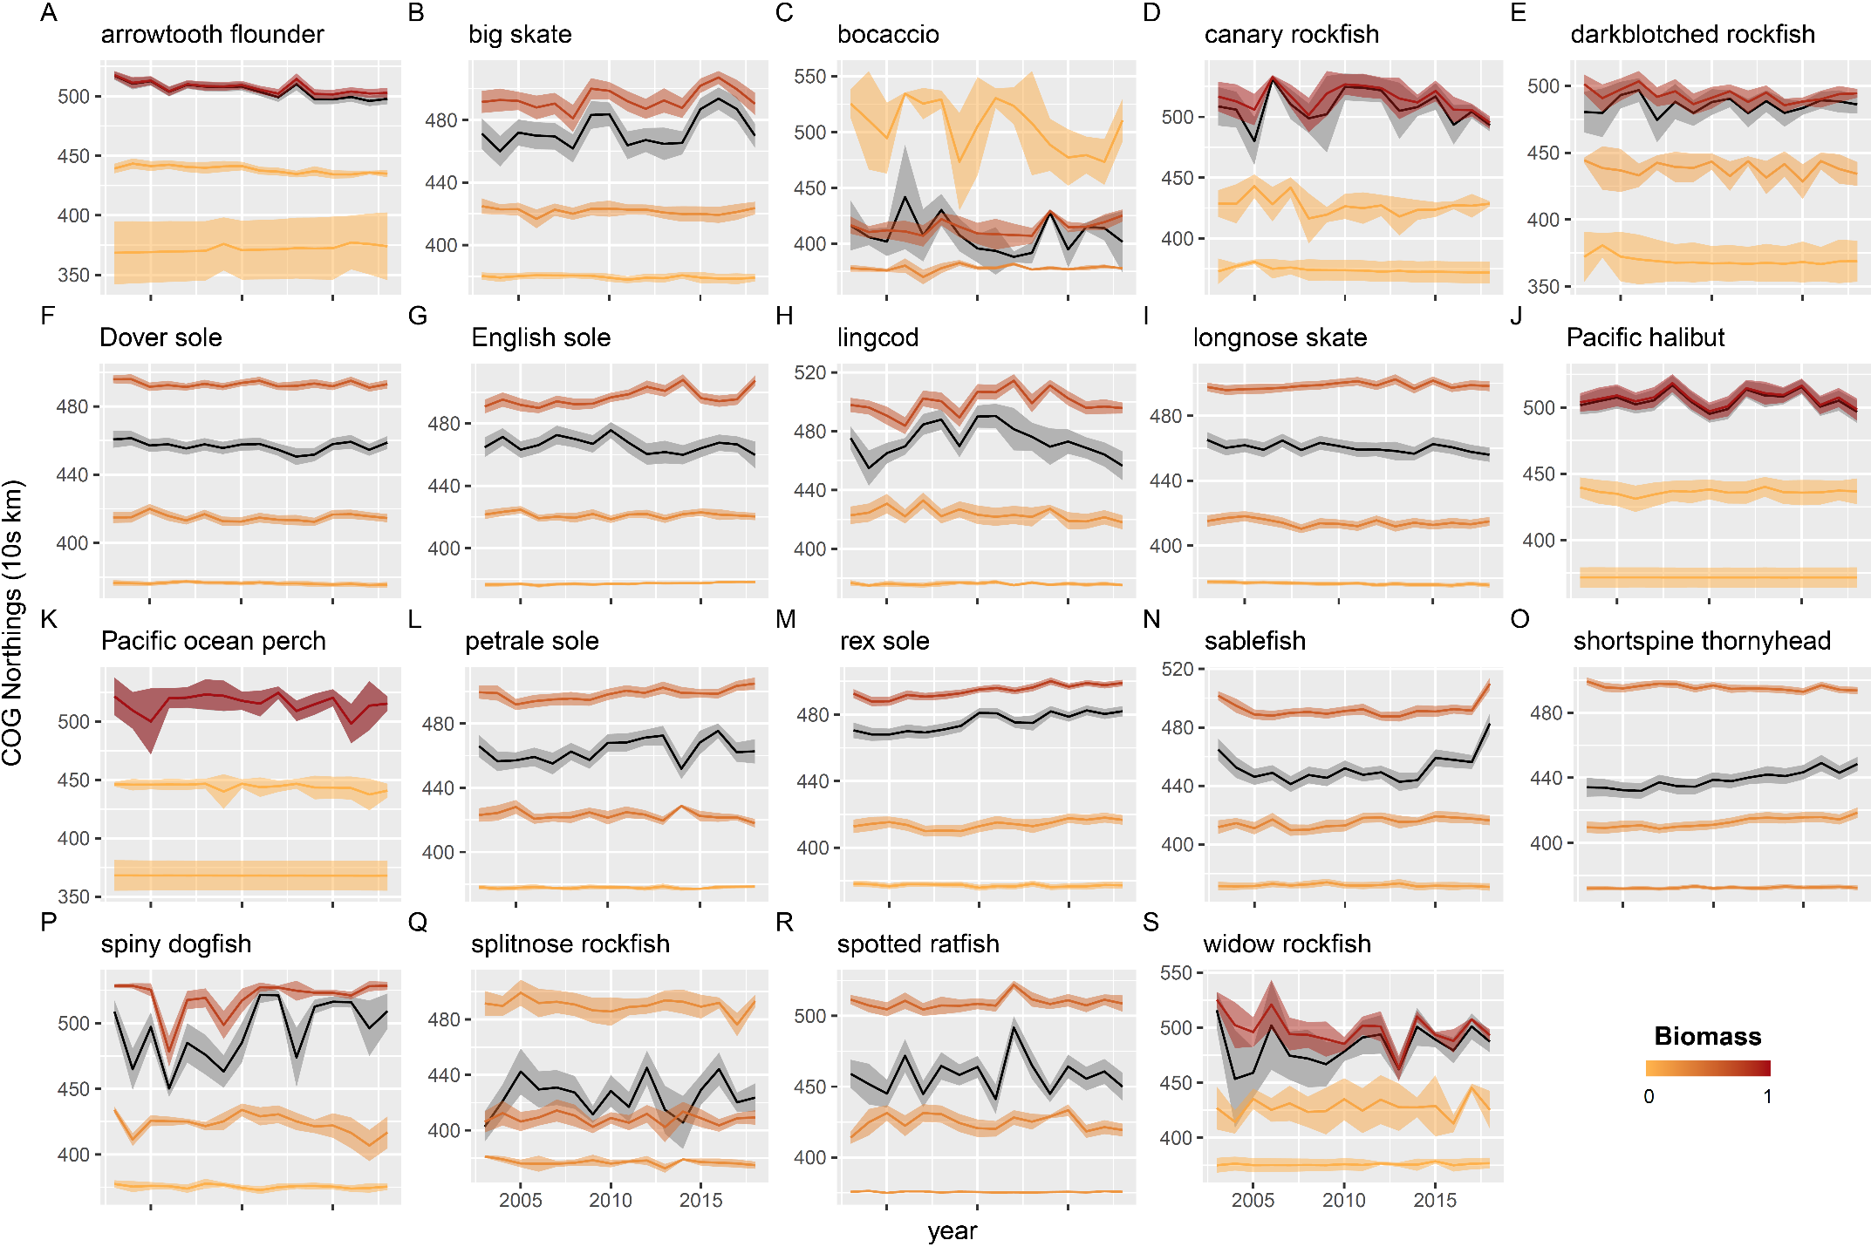

Figure S3. Time series of the center of gravity (COG), or density-weighted mean latitude, for the full set of species analyzed in figure 4 of the main text. The black line with grey interval represents the COG calculated on coastwide predicted species density, whereas the colored lines are the COGs for each unique biogeographic region (separated by Cape Mendocino, California in the north; Point Conception, California in the south). Line color represents the proportion of a species biomass in a given region.